**Project Report**

**1 INTRODUCTION**

1.1Overview

A startup is a company in the early stages of development that is set up by one or several people to enter an existing market with unique products or services. Startup companies often face insufficient capital to fund their business operations to be at the same level as already established companies.

1.2 Purpose

innovative products or services. While most small businesses might intend to stay small, a startup focuses on fast growth in a designated market. Usually, such companies start as an idea and gradually grow into a viable product, service or platform.

A startup analysis is essential to the success of any startup business. It allows entrepreneurs to identify the key areas that need improvement and make necessary changes early on. Doing a startup analysis also allows startups to track their progress and ensure that they are on track to achieve their goals.

The purpose of a startup is multi-faceted, depending on the individual or team behind the venture. Generally, though, the purpose of a startup is to create something new and innovative. A startup is often the first step in launching a business venture, and is the beginning of an entrepreneurial journey.

Startups are created to fill a void in the marketplace, or to take advantage of a new trend or opportunity. They are often driven by ambitious individuals with a desire to make money or have an impact on the world by developing a product or service that is unique. Startups often start small and grow as they attract funding or customers.

Startups can be used to test out ideas, explore new technologies, and develop products and services that can eventually turn into successful businesses. Startups often rely on venture capital funding to get off the ground and are typically run by entrepreneurs who are passionate about their ideas.

**2 PROBLEM DEFINITION & DESIGN THINKING**

2.1 Empathy map

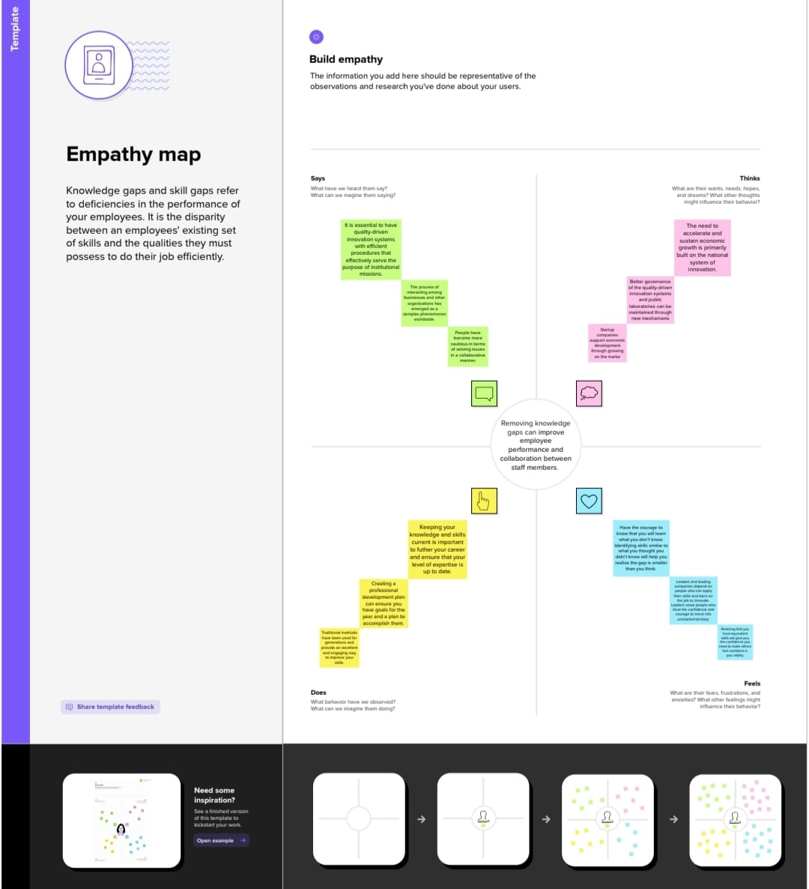

2.2 Ideation & Brainstorming map

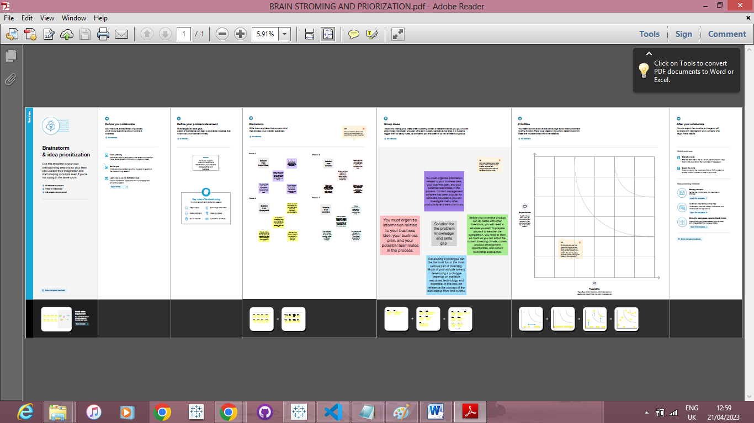

**3 RESULT**

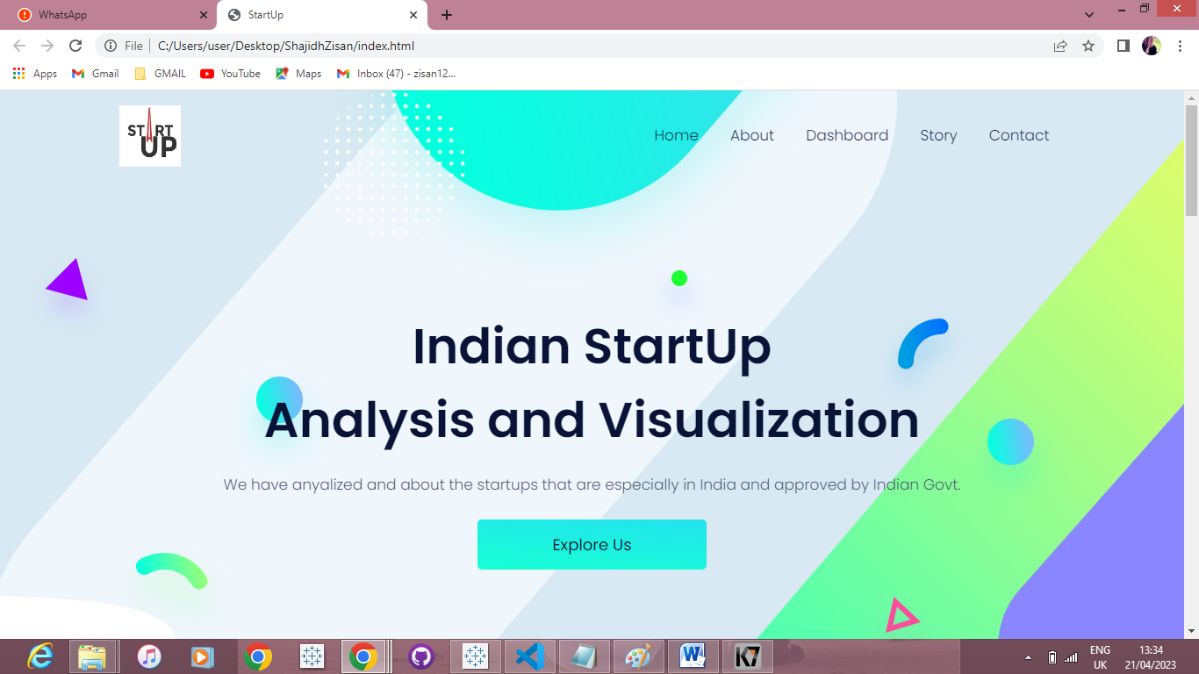

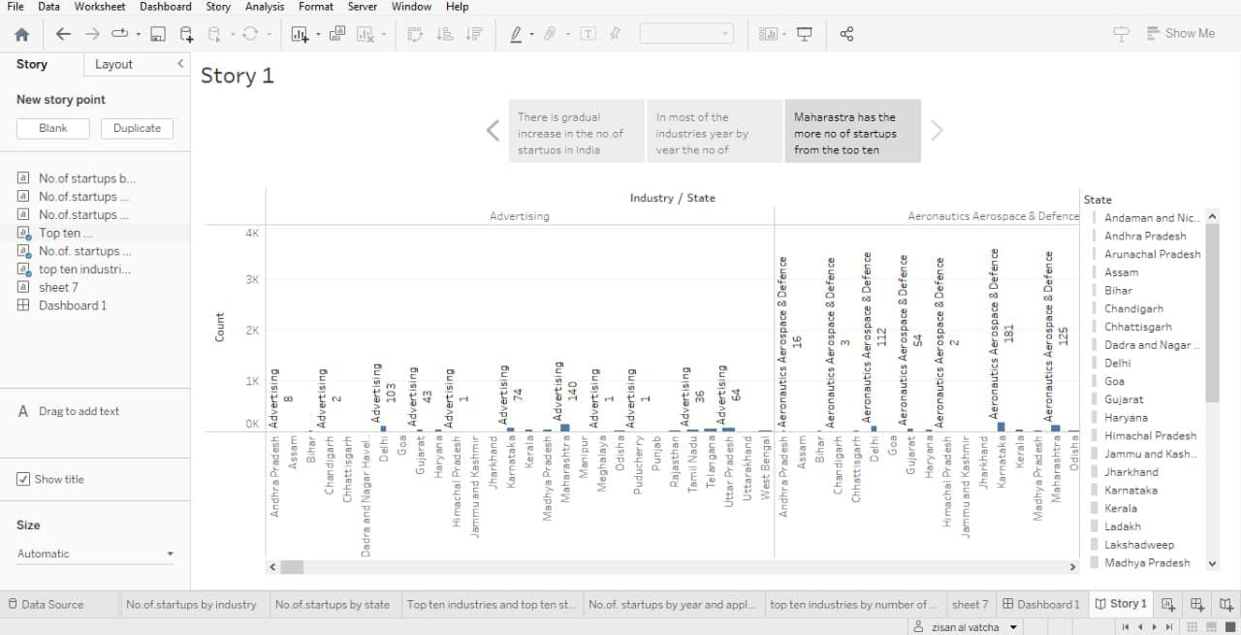

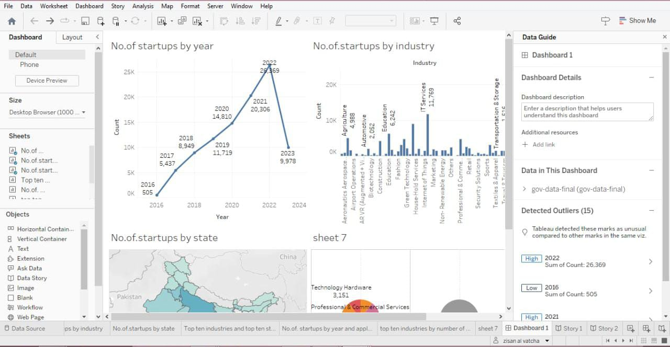

**4 ADVANTAGES & DISADVANTAGES**

Advantages

1. Agility

Startups are smaller and less structured. They are also innovative and keep improving their business models, processes, and portfolio. These allow them to adapt to disruptive technologies and changes in market conditions. Established competitors face vested interests, a historic path, and a strong team culture. This makes them resistant to change.

2. Efficiency (Lean and Mean)

Established companies have high administrative overheads. Startups offer their services in a more efficient, cost-effective and competitive manner. They are likely to be aware of their limitations and tend to focus on their core strengths. This causes them to partner with other small organizations. Customers often benefit with a superior value proposition.

3. Team Culture

Employees of large corporations get attracted by prestige and big salaries. They easily lose sight of the company’s vision, mission and values and the success of its customers. Startup employees form a close-knit community that shares passion, beliefs, and values. They must work together for the good of the company, its customers and the world at large.

4. Personalization

Startups deliver their products and services with a personal touch. This creates a uniquely personal experience for their customers. Startups also take time to study and understand their customers’ business requirements. This allows them to build lasting relationships with specific offerings and responsive solutions.

5. Versatility

Startup employees multitask and the salesperson could double up as the relationship manager. This adds continuity to customer relationships and enables startups to respond to emergencies.

Disadvantages

1. Risk

Most startups fail within their first year of operations, so the risk of failure is high. Working under such high risk can blur a startup’s strategic vision. So they either fail to seize market opportunities or overestimate their sales projections. High risk also hinders a startup’s ability to attract experienced and competent staff.

2. Compensation

It takes blood, sweat, and tears to build a company, and long working hours are the norm for startups. The rewards might be low since it takes time to generate revenue and make profits. Some startups give up since it’s demotivating to work without proper compensation.

3. Market Access

Many customers prefer a business that they have worked with over a new startup. Besides it is more expensive to acquire new customers than to retain old ones. Without a customer base, understanding market needs also becomes a real struggle. All these factors combined increase the cost of business development for startups.

4. Team Composition

Some startups are born out of desperation since the founder could not find or hold on to a job. Such founders often struggle to build a team that the business needs to succeed. A successful startup requires founders/co-directors with complementary personalities and competencies. Even then disagreements can creep in when the going gets tough.

5. Resources

Growth hacking, cloud computing, and venture capitalism allow startups to gain market entry. Most startups operate on a shoestring budget, against competitors that are well-resourced. It gives the competitors an edge in product development, sales, and marketing. They use that edge to push startups out of the market when they become a threat.

**5 APPLICATIONS**

Because new businesses must adapt quickly to internal and external market pressures in order to survive, a startup culture also promotes business agility and adaptability as being key virtues. The workplace values supported by startup cultures are increasingly resonating with business leaders at large organizations.

**6 CONCLUSION**

A business plan conclusion is a summary of a business plan's strengths designed to convince the reader of the company's success. Because companies typically create business plans to get funding or investors, the conclusion should focus on how the organization makes money and why it is a good investment.

Entrepreneurship is a mind-set, an attitude; it is taking a particular approach to doing things. The motivations for becoming an entrepreneur are diverse and can include the potential for financial reward, the pursuit of personal values and interests, and the interest in social change.

**7 FUTURE SCOPE**

**Robotics:** There is an enormous level of new interactions that are in store between people and machines.

**Transportation tech:** There are a number of self-driving startups already. We will come to a point where the cars will become like PCs - where the hardware becomes less important/commoditized and there will be a host of software players who will help run the system & add features.

**Energy tech:** As solar becomes cheaper than conventional fuels, it will take over the grids everywhere. That will require smart load balancing, better battery technologies.

**Space tech:** With nanosatellites able to be built by anyone and low orbit rockets launched by private companies, we will come to a point where there will be a number of tiny SpaceX all building equipments for the new space race. Over 100 countries will wait for their services to get them to space.

**Health tech:** There is already some tech in healthcare, but it is a sector that has evaded big transformation and the regulations have aided that. Over the next 10 years, there will be new challenges imposed due to rapidly greying population and bankrupt governments will be forced to open up this sector to automation